(Description of the Model: Evangelos’ workflow diagram, definition of SOC, Power Consumption/Cost will be calculated out of SOCs, alternative plans and graphs)

(5.1 NHTS: TexasTable.mat, unit of time is minute, we investigate from t = 0 to t = 1440, legend of the terms)

**5.2 State of Charge (SOC)**

**5.2.1 State of Charge with Regular Charging Plan**

In order to find the total power consumption and electricity cost of the microgrid, we first found the SOCs of each vehicle for a day, from *t* = 0 to *t* = 1440 minutes. Figure A illustrates the steps to calculate SOCs with the NHTS travel data.

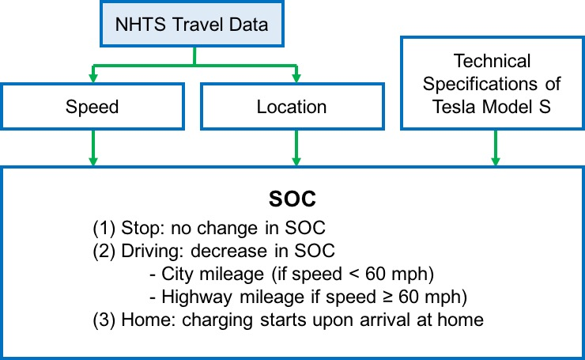

Figure A: Calculation of SOC

First, the function *FUNC_speed.m* found the speed of each vehicle at *t*. The calculated speed values were later used to determine the power discharge rate of a vehicle at *t*. For example, if the vehicle’s speed is higher than 60 mph at a certain point, the vehicle consumes 0.33 KWh of electricity per mile, which is the highway fuel economy of Tesla Model S. The implementation code is presented in Figure B.

Next, we executed the function *FUNC_location.m* to find the location of each vehicle at *t*. Since we are assuming that all vehicles charge only at home, we are only interested in if a vehicle is parked at home (charging), parked at other locations (no change), or moving on the road (discharging). Thus, if the WHYTO value at *t* is not equal to 1 (home), the location at that time is defined to be 0 (other locations). The implementation code is shown in Figure C.

In order to calculate the SOC at *t*, we referred to the technical specifications of Tesla Model S. The values that were used in our simulation include *Battery Capacity* = 85 KWh, *Charge Rate* = 9.6 KW, *City Fuel Economy* = 3.00 mi/KWh, *Highway Fuel Economy* = 3.03 mi/KWh.[A]

% select the row for a given HOUSEID

% only select the first member of a household (PERSONID == 1)

rows = table.HOUSEID==houseid & table.PERSONID==1;

% create speed profile

for i=1:height(subtable)

t_start=subtable.ENDTIME(i)- subtable.TRVL_MIN(i);

if t_start<1

t_start=1;

end

t_range= t_start:(subtable.ENDTIME(i) - 1);

speed(t_range)= subtable.TRPMILES(i)/subtable.TRVL_MIN(i);

end

Figure B: Implementation to find the speed of every vehicle at *t*

for i=1:height(subtable)

if (subtable.ENDTIME(i)- subtable.TRVL_MIN(i))>0 && subtable.TRVL_MIN(i)>0

period= subtable.ENDTIME(i)- subtable.TRVL_MIN(i): subtable.ENDTIME(i)-1;

% vehicle is on the road

for t=period(period>0)

location(t)=-1;

end

% consider the case when the vehicle is not moving

% set location = 1 (home) or 0 (other locations)

t=t+1;

if t<1

t=t+1;

end

end

Figure C: Implementation to find the location of every vehicle at *t*

With the calculated speed and location values from t = 0 to t = 1440 and the battery specifications of Tesla Model S, *FUNC_SOC.m* finds the SOC curve of each vehicle. As described in Figure A, if a vehicle stops at a location other than home, there is no change in SOC. If a vehicle is on the road, the discharging rate is determined by the speed of the vehicle. Battery charging starts as soon as a vehicle arrives at home—at time *t* when the car’s *location* value first changes to 1.

Figure D shows the SOC curve of a sample vehicle (HOUSEID = 32957150). The flat line segment marked in blue indicates that the vehicle is parked somewhere other than home during the time period. The upward curve, marked in red, represents the charging of the vehicle, which starts as soon as it comes back home.

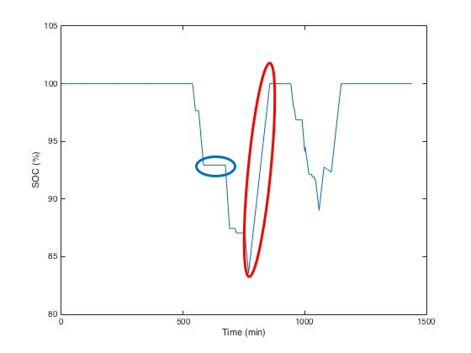

Figure D: Sample SOC Curve

After SOCs of all vehicles are found, the vehicles whose SOC goes below 0 at any point in time are excluded from our analysis. Since our model does not consider the possibility of recharging electric vehicles at charging stations, the SOC vector of a vehicle that travels further than approximately 250 miles—the driving range of Tesla Model S—without coming home includes negative numbers. We converted the SOC vectors of such vehicles into NaN’s, as shown in Figure E.

% Convert SOC vectors with negative elements into NaN’s

if any(SOC<0)

SOC=NaN;

end

Figure E: Implementation to delete vehicles with negative SOC elements

**5.2.2 State of Charge with Alternative Charging Plans**

After each vehicle’s regular SOC vector was determined, we found the SOC vectors when alternative charging plans were applied. As illustrated in Section 4.X in Figure X, the most notable feature in the alternative plans is that there are pauses of random lengths before and after charging steps. For example, Figure X(f) shows that there are 4 pauses in the Alternative Plan 5. Once the total amount of time available for all of the pauses is determined, the length of each pause is determined relatively by the other pauses. The implementation code is available in Figure F.

If an alternative charging plan is applied, a new 1×1440 SOC vector is generated as an output. In the new alternative SOC vector, the elements in the time interval between *thome* and *tleave* are replaced. If a vehicle leaves and comes home multiple times, there can be more than one time intervals in which the SOC values are replaced.

% pauseTotal is the sum of all pauses between charging steps [in minutes]

pauseTotal = t_leave - t_home - t_charge - 60;

% In this alternative plan, there will be four pauses

R = rand(1,4);

pause1 = round((R(1)/sum(R))*pauseTotal);

pause2 = round((R(2)/sum(R))*pauseTotal);

pause3 = round((R(3)/sum(R))*pauseTotal);

pause4 = round((R(4)/sum(R))*pauseTotal);

Figure F: Implementation to randomly determine the lengths of pauses

**5.3 Power Consumption**

To analyze the effect of the EV microgrid on grid robustness, the total power consumption from the grid should be calculated. Charging a Tesla Model S vehicle consumes 9.6 KW of power from the grid. With SOC vectors, the daily total electricity consumption of all vehicles in the microgrid can be calculated by a simple relation.

if SOC(t)-SOC(t-1)>0

electricity(t)=car.ChargeKW

end

Figure G: Implementation to calculate power consumption at *t*

As seen here, if a vehicle’s SOC is increasing at a certain time, it must be charging and its power consumption rate at the given moment is 9.6 KW.

[A] https://www.teslamotors.com/models